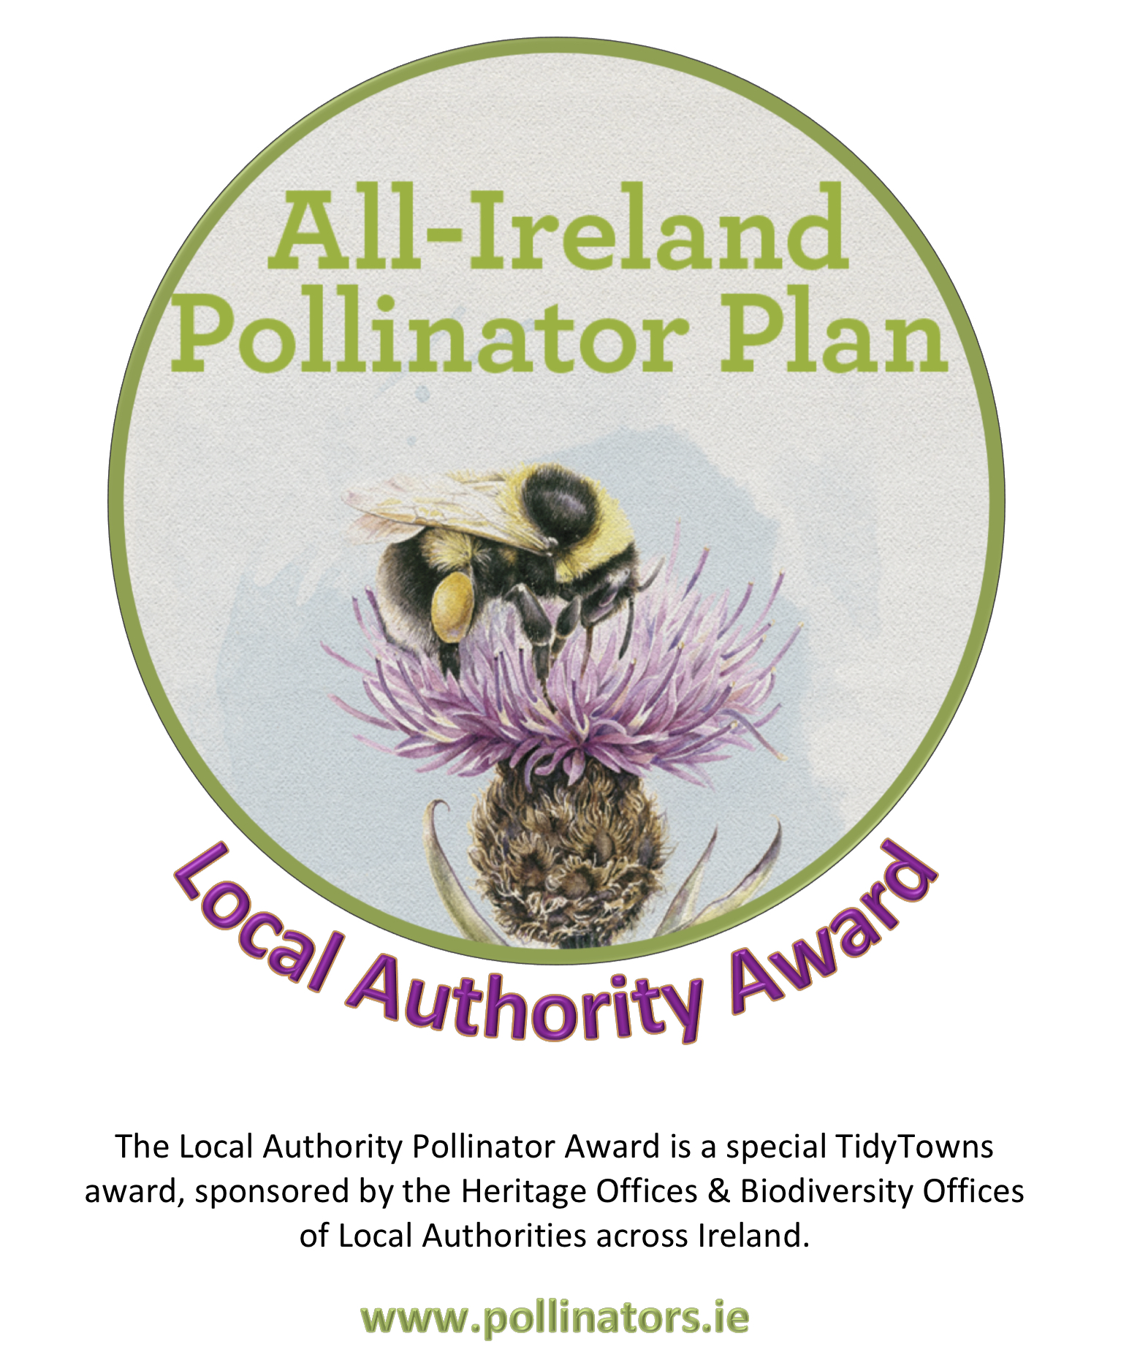
Local Authority Pollinator Award 2019

About the Award - €9,000 prize money for 8 communities across Ireland
The Local Authority Pollinator Award aims to encourage TidyTowns groups to implement pollinator-friendly actions in their towns and villages as part of the TidyTowns competition. Irish bees, crucial to the pollination of our plants, trees and vegetables, are in decline. This is because we’ve drastically reduced the areas where they can nest and the amount of food our countryside provides for them. The aim of the award is to reverse this trend by encouraging TidyTowns groups to take simple pollinator-friendly measures in their local area. The Local Authority Pollinator Award supports the All Ireland Pollinator Plan 2015-2020 and is sponsored by the Heritage Offices & Biodiversity Offices of Local Authorities across Ireland. There are two award categories:
- Village or Small Town
- Large Town or Urban Centre
A prize of €1,000 will be awarded to the four Regional winners in each of the two categories. Out of these eight regional winners, one overall national winner will receive an additional €1,000. Awards will be given to all categories subject to satisfactory criteria.
For more details see www.TidyTowns.ie or www.pollinators.ie

What types of activities are we looking for?
Local communities can lead the way in driving a better and more sustainable balance for pollinators, and bringing more natural, flower-rich pockets back into our landscape. A guidance document for local communities is available on the Pollinator Plan website, which outlines 24 actions you can take to help pollinators in your local community. See http://pollinators.ie/communities/ to download a copy of our ‘Local Communities: Actions to help Pollinators’ guidance document.
On our website, you will also find lots of useful resources, including videos that explain some of the actions, interviews with winning TidyTowns groups, presentations that explain the plan, as well as pollinator-friendly planting lists and case studies. You are welcome to screen any of our videos in a group setting to help create awareness of the Pollinator Plan.
We would highly recommend you take the time to research all the resources on www.pollinators.ie as there is lots of easy to use guidance, including guidance for other sectors, such as Schools, Gardens, and Businesses, which may give you ideas on how you can get everyone involved in your town or village.
The evidence-based actions offered by the All-Ireland Pollinator Plan to help pollinators are either zero or low-cost, and all are very clearly explained. They range from changing your mowing regime in certain areas; to planting pollinator-friendly trees and shrubs; drilling holes in wooden fencing for solitary bees to nest; and raising awareness by promoting the junior All-Ireland Pollinator Plan to youth groups and schools in your community. Lots of possible actions are suggested, enabling local groups to identify those that are most appropriate for their own area. The more of these actions you can take, the more pollinator friendly your local area can become. We particularly encourage a whole-town approach, rather than isolated projects – as it’s more effective for the pollinators and will have a greater positive impact for biodiversity.

INSTRUCTIONS TO ENTER
- We place a particular emphasis on a ‘whole town’ approach, rather than single projects in one area of town, as this is better for pollinating insects and will have greater long term impacts for biodiversity.
- Please fill in the attached application form to let us know in no more than 3,000 words how your community is implementing pollinator-friendly actions.
- This application form refers to work undertaken from May 2018-May 2019.
- Only ONE application will be accepted per group, and applications must come from an official Tidy Towns group (as agreed with the National Tidy Town Unit).
- Questions 1-7 below refer directly to Pollinator-friendly Actions outlined in the guidance document, Local Communities: Actions to help pollinators, which can be downloaded from the Pollinator Plan website http://pollinators.ie/communities/ It is advised you refer closely to this document when planning your town’s actions, checking off those you want to adopt in your town/village.
- Points are allocated for each question on this application form. All questions must be answered, using this form only. Omitting questions will cause loss of points.
- Your entry must consist of a single file (comprising the application form, with your photos and map embedded) (Word or PDF) less than 10MB in size.
- Please provide an A4-size map of your town/village marking the locations of each of your pollinator-friendly actions. A hand drawn map is perfectly acceptable. This makes it easier for us to see clearly what pollinator actions you have undertaken throughout your town/village. The map must be embedded within the application form.
- Please provide photographs to help demonstrate your work. Photos must be captioned, dated and embedded within the application form.
- Email your entry to pollinators@biodiversityireland.ie, with “Pollinator Award: Your Town/Village name” in the subject line.
- Read and tick the Data Protection paragraph below.

Closing Date: Friday 17th May 2019

Judging the Award:
All entries will be assessed by a panel of suitably qualified judges including Local Authority Heritage Officers & Biodiversity Officers, and National Biodiversity Data Centre staff.

All-Ireland Pollinator Plan: Local Authority Pollinator Award 2019

ENTRY FORM

Name of Tidy Towns Group and County: ...............................................................................................

TidyTowns Region (as per your national Tidy Towns application form)..................................................

Tidy Towns Population Category (A-H) (as per your national Tidy Towns application form):

................................................................................................................................................................

Nominated contact in Tidy Towns Group: ..............................................................................................

Postal Address: .......................................................................................................................................
.................................................................................................................................................................

Phone number: ................................................. Email:........................................................................
Data Protection
I confirm that my contact details as above may be used in communications relating to the All Ireland Pollinator Plan Local Authority Award. Any personal information which I provide in this way is not made available to any third parties, save as required by law, and is used by the National Biodiversity Data Centre and Local Authority Heritage Officers/Biodiversity Officers only in line with the purpose for which I provided it. Any personal information which I provide will be treated in accordance with the General Data Protection Regulation.
Please tick your consent to process your data for this application

1. One priority of the Pollinator Award is to protect the pollinator-friendly habitats that you already have, and focus on how you manage them. (See Action 1 in guidelines: Local Communities: Actions to help pollinators). Please provide 3 examples of how you’re doing this, and why you choose these habitats/areas. Mark these 3 areas on your map. (10 points)

2. Provide details of the changes that you made to your mowing regime to help pollinators (Actions 2-4). Please provide details of locations, size of areas etc., and mark the areas on your map).
(15 points)

3. Provide details of any pollinator-friendly planting that you provided (Actions 5-11). Please provide the names of all pollinator-friendly plants used, and mark these areas on your map.
(15 points)

4. Provide details of nesting habitats that you provided for wild pollinators, and mark these areas on your map. (Actions 12-15 explain how to create bare earth for mining bees as well as holes in wood for cavity-nesting bees). Please refer to our ‘How to guide: Creating wild pollinator nesting habitat’ at http://pollinators.ie/resources/ (5 points)

5. Provide details of how you reduced the use of pesticides. (Action 16-17) (10 points)

6. Provide details of how you raised public awareness of pollinators in your local area. Action 18-21). If your group uses social media please include links to Facebook pages or Twitter handles. (10 points)

7. Are you measuring the impact of your work (Action 22-23)?
7a. Have you added your pollinator sites to the online mapping system called ‘Actions for Pollinators’? This site allows us to track the build-up of food and shelter for pollinators across the island (see https://pollinators.biodiversityireland.ie/) (5 points)
Yes ☐ No ☐

7b. Are you taking part in the National Biodiversity Data Centre’s Bumblebee Monitoring Scheme? (see http://www.biodiversityireland.ie/record-biodiversity/surveys/). (5 points)

Yes ☐ No ☐

8. What are your next THREE priorities or future projects for pollinators for the coming year?
(5 points)

9. Please provide captioned photographs throughout your application which illustrate the work that you have done
(10 points)
Photos included ☐

10. Please provide an A4 size map of your town/village highlighting the locations of all your pollinator-friendly actions. This makes it easier for us to see clearly what pollinator actions you have undertaken throughout your town/village. (10 points)

Map included ☐

TidyTowns Terms and Conditions apply.

